**MEDICINE STORE MANAGEMENT PLATFORM FOR SMALL PHARMACIES**

Capstone Project Presented to

CEDAR College, Inc.

National Highway

Cadiz City, Negros Occidental

In Partial Fulfillment of the

Requirements for the Degree of

Bachelor of Science in Information Technology

Christian Dominique A. Abella

Lhenel Ann Jaira L. Gallo

Ana Liza B. Masgon

Richel Mae J. Villa

December 2024

**CHAPTER I**

**INTRODUCTION**

**Project Context**

In today’s healthcare environment, small pharmacies are essential for ensuring that local communities have access to necessary medications. However, many of these pharmacies encounter difficulties with inventory management, prescription tracking, and customer service due to limited resources and outdated systems. Inefficient processes can lead to medication errors, stockouts, and dissatisfied customers, ultimately compromising customer care and the sustainability of the business.

To address these challenges, the "Medicine Store Management Platform" has been developed to streamline operations for small pharmacies. This integrated solution enables pharmacy staff to manage inventory efficiently, process prescriptions accurately, and maintain detailed customer records. With features such as real-time inventory tracking, automated restocking alerts, and comprehensive sales reporting, the platform empowers small pharmacies to optimize their workflows and enhance service delivery. By improving operational efficiency, this solution aims to support pharmacies in providing better customer care and building community trust.

**Project Description**

The "Medicine Store Management Platform" is an all-encompassing solution aimed at improving the operational efficiency of small pharmacies. This platform allows pharmacy staff to manage inventory effectively, track prescriptions, and maintain comprehensive customer records, enabling them to concentrate on delivering quality care to their customers.

With features like real-time inventory tracking, automated restocking alerts, and streamlined prescription management, the platform ensures that pharmacies are consistently stocked with essential medications. Users can easily categorize and oversee inventory, gaining valuable insights into stock levels and expiration dates.

Furthermore, the platform includes customer management tools that help pharmacies maintain accurate customer records and provide personalized service. Sales and inventory reports assist pharmacy owners in making informed business decisions, ultimately enhancing profitability and customer satisfaction.

Designed with a user-friendly interface, the "Medicine Store Management Platform" is accessible to pharmacy staff with varying degrees of technical knowledge, facilitating easy adoption of the system. By incorporating crucial features such as inventory management, prescription tracking, and customer engagement, this platform empowers small pharmacies to streamline their operations, improve customer care, and foster strong community relationships.

**Objectives**

The primary objective of the "Medicine Store Management Platform" is to tackle the operational challenges encountered by small retail pharmacies. Furthermore, the specific objectives are as follows:

1. To establish a centralized inventory management system that enables pharmacies to monitor stock levels in real-time, thereby reducing issues related to overstocking and understocking and ensuring that essential medications are always available;
2. To automate the tracking of prescriptions and order management, which will minimize manual record-keeping errors and enhance the accuracy and speed of service, ultimately improving customer satisfaction; and
3. To offer comprehensive reporting tools that empower pharmacy owners to analyze sales data and customer trends, facilitating informed decision-making to enhance operational efficiency and profitability.

**Scope and Limitation**

The "Medicine Store Management Platform" is designed to assist small pharmacies, including online medicine stores, in streamlining their operations by centralizing inventory management and enabling real-time monitoring to prevent overstocking and medication shortages. The system automates prescription tracking and order management, reducing manual errors and enhancing transaction speed and customer service for both in-store and online purchases. It features a user-friendly interface and incorporates robust security measures to protect sensitive information.

However, the system has several limitations. It primarily targets small pharmacies, which may restrict its compatibility with certain existing systems, including Point of Sale (POS) systems, and impact data accuracy. Advanced features, such as integration with external software or automated inventory replenishment, are not included. Additionally, the current version does not support multi-location management, which could be a drawback for pharmacies with multiple branches, nor does it offer extensive reporting capabilities that could enhance business insights.

**Definition of Terms**

1. **Medicine Store**

A retail location where pharmaceutical drugs and other health-related products are sold.

Operationally, this refers to small pharmacy outlets that will use the software to manage inventory and sales operations.

1. **Management**

The process of controlling and overseeing resources or personnel within an organization.

Operationally, this refers to the administrative tasks the software performs to organize, control, and monitor various aspects of pharmacy operations, such as inventory, sales, and staff management.

1. **Platform**

A set of technologies that serves as a foundation for developing other applications, processes, or technologies.

Operationally, this is the software solution or application that serves as the central tool for managing pharmacy operations, offering features like inventory tracking, sales reporting, and customer management.

**4. Small Pharmacies**

Independent or small-scale retail outlets that sell medicines and healthcare products, typically with limited employees and resources.

Operationally, these are the target users of the platform who need a specialized, cost-effective solution to efficiently manage their day-to-day operations.

**5. Inventory Management**

The process of ordering, storing, using, and selling a company’s inventory.

Operationally, this is a key feature of the platform that allows pharmacies to track stock levels, manage reorder points, and avoid overstocking or stockouts.

**6. Sales Tracking**

The process of recording and analyzing sales data to monitor the performance of products and sales strategies.

Operationally, this feature within the platform logs each sale, generates sales reports, and helps pharmacies analyze trends to optimize their product offerings.

**7. Prescription Management**

A system or process for managing and fulfilling medical prescriptions within a pharmacy.

Operationally, this module in the platform enables pharmacists to receive, process, and track customer prescriptions efficiently.

**8. Customer Relationship Management (CRM)**

A technology for managing a company’s interactions with current and potential customers.

Operationally, this platform feature helps pharmacies manage customer data, track interactions, and improve customer service.

**9. Compliance**

The act of adhering to laws, regulations, and guidelines set by governing bodies.

Operationally, this ensures that the platform meets legal and regulatory requirements, such as drug tracking and customer confidentiality, which are essential for pharmacy operations.

1. **User Interface (UI)**

The means by which users interact with a computer system, including screen layouts, controls, and navigation.

Operationally, this encompasses the design and layout of the platform’s dashboard and modules, which pharmacy staff use to perform their daily tasks efficiently.

**Review of Related Literature**

According to Alvin Gino M. Bautista (2020), a study aimed at evaluating the financial management practices of small-scale pharmacy owners in Cabanatuan City, Philippines, specifically focused on cash flow and accounts payable management. The research encompassed 16 small pharmacies located near government hospitals, such as Dr. Paulino J. Garcia Memorial Research Center, Manuel V. Gallego, Cabanatuan City Hospital, and Eduardo L. Joson Provincial Hospital. This study included both sole proprietorships and partnerships, while excluding corporate pharmacies in the vicinity. The outcomes of this research are significant for small pharmacy owners, as they provide insights into effective management strategies that can enhance efficiency in handling cash and accounts payable. The study’s recommendations aim to improve the financial management techniques of small pharmacy businesses.

Aldrin Nico R. Plantado, et al. (2023) describe the establishment and functioning of an online telepharmacy service in the Philippines, analyzing its usage and examining the health information-seeking behaviors of users during the COVID-19 pandemic. The service employed multiple platforms for query handling, communication, and marketing. Data collected from submissions between March 20 and May 31, 2020, were analyzed, focusing on parameters such as submission timing, response rates, user feedback, demographic details, and inquiry subjects. In the context of the "new normal," it is crucial to embrace alternative platforms to complement traditional health information sources. An online telepharmacy service can significantly contribute to delivering and clarifying medication-related information as part of primary healthcare.

Frances Lois U. Ngo, et al. (2024) highlights the pivotal role of community pharmacists as healthcare professionals with direct access to patients during the COVID-19 pandemic. However, prior research documenting the challenges, adaptive strategies, and opportunities faced by community pharmacy practice in the Philippines during this time is scarce. This study seeks to outline the difficulties encountered by community pharmacists, the adaptive measures they adopted, and the opportunities to improve community pharmacy practices that arose due to the pandemic. The identified challenges led to various adaptive strategies, further underscoring the vital function of community pharmacists in the healthcare system.

Eric Parilla, et al. (2022) investigates the connection between inventory management strategies and service delivery in healthcare facilities across Ilocos Norte, Philippines. The research included 16 healthcare establishments and surveyed 80 patients, chosen through a convenience sampling method. Utilizing a quantitative research framework and a causal research approach, the study aimed to explore the relationship between the independent and dependent variables. It identified five primary inventory management practices: pharmacy premises and storage, drug information, safety and security, personnel and stock control, and monitoring. Hospitals were evaluated on service quality across four areas: admissions, treatment, environment and facilities, and discharge processes. The results indicated a significant correlation between personnel and stock control, monitoring, and overall service quality. The study also offered implications, conclusions, and suggestions for improvement.

Venice Lara Soliveres, et al. (2024) emphasize that effective inventory management is crucial for pharmacies, ensuring the constant availability of pharmaceutical products while minimizing the risk of stockouts or overstock situations, thereby enhancing customer satisfaction. This study aimed to evaluate the inventory management practices of small-scale pharmacies in selected towns in Cavite, Philippines. The researchers utilized a descriptive research approach and purposive sampling, including 50 legally registered small pharmacies as participants. The results indicated that most pharmacies were sole proprietorships, employing between one and nine staff members, with estimated assets of P3,000,000 or less. They had been in operation for either one to three years or ten years and beyond. The study provides valuable insights that could serve as a foundation for small-scale pharmacies to refine their inventory management practices. It offers suggestions for improving existing methods related to sourcing, storing, and selling, thereby enhancing the monitoring and control of inventory movements from acquisition to transaction.

In addition, Caterina Cavicchi and Emidia Vagnoni (2020) discuss the increasing demand for community pharmacies to contribute to sustainable healthcare systems by engaging in integrated care models and taking on significant educational responsibilities in environmental conservation. These developments have resulted in heightened competition in the retail pharmaceutical sector and a shift toward a service-oriented business framework. Such changes necessitate a reevaluation of the business models of these hybrid organizations, which blend profit-driven, social, and environmental objectives. The paper presents a sustainable business model (SBM) that enables community pharmacies to enhance public health through their existing roles and the expansion of those roles. The COVID-19 pandemic underscores the importance of prioritizing human health within the sustainable development agenda and raises questions about extending patient-oriented services provided by community pharmacies. The SBM presents an opportunity for community pharmacies to strengthen their position within the healthcare workforce, particularly in times of global health crises. Additionally, the SBM supports the incorporation of sustainability into everyday pharmacy practices, though it requires customization to fit the unique context of each business, considering health policies and regulations in various countries.

Kevin Chu and Juan Manuel Martínez Pizano (2019) note that pharmaceuticals represent a substantial portion of global healthcare spending, making effective inventory management vital for the financial stability of the retail pharmaceutical industry. The retail pharmacy examined in this study faced challenges associated with managing high-performance inventory strategies. The analysis utilized descriptive analytics, such as demand frequency, variability, and profit, alongside data mining and quantitative models, including inventory control, sensitivity analysis, and scenario analysis. These methodologies aimed to identify optimal replenishment strategies for a prioritized group of SKUs, factoring in elements such as forecast duration, stock-out penalties, and customer service levels. The findings reveal the trade-off between taking advantage of supplier discounts and incurring higher costs associated with excess inventory, as well as the need to balance holding costs with stock-out penalties. The research recommends employing the (Q, R) policy for high-profit SKUs, which could achieve an average cost reduction of 33%, and the (s, S) policy for low-profit SKUs, leading to a potential 37% cost reduction.

Soetkin Deschepper (2021) indicates that Belgian hospitals have been mandated to collaborate within locoregional networks since January 1, 2020. This collaboration presents an opportunity for hospitals to share services, such as establishing centralized hospital pharmacies. The study aimed to evaluate the operational feasibility of organizing a centralized hospital pharmacy to oversee the drug distribution process across a network of hospitals. A case study was conducted using a literature review and interviews with a Belgian best practice network, GZA-ZNA. The assessment of operational feasibility for centralizing the hospital pharmacy within the E17-network was conducted through semi-structured interviews with seven chief pharmacists and one pharmacist involved in network projects. To enhance the quality and external validity of the research, insights from the vision document of Zorgnet-Icuro were also included, with further clarification obtained through an interview. While the vision document outlined the fundamental needs for centralizing hospital pharmacies across Belgian networks, the case study specifically focused on identifying opportunities, challenges, and prerequisites for centralization within the E17-network.

John A. Dougherty (2020) describes how the Gregory School of Pharmacy developed a co-curricular program designed to enhance both didactic and experiential learning while adhering to the standards set by the Accreditation Council for Pharmacy Education (ACPE). The program aims to improve student learning outcomes, provide constructive feedback, document the achievement of learning objectives, and track student progression. In 2016, the faculty at Samford-McWhorter recognized the necessity to update the Doctor of Pharmacy curriculum to better prepare graduates for the evolving landscape of pharmacy practice and healthcare. A faculty-led Curricular Transformation Task Force organized retreats, implemented workgroups, and crafted a comprehensive curricular framework. The Assessment Committee established program competencies based on endorsed documents from the academy, including CAPE, EPAs, IPEC, and ACPE standards. Furthermore, both the Curriculum and Assessment Committees devised a quality assurance model to oversee the curriculum's implementation each year. Following extensive collaboration, which involved debates, retreats, meetings, and discussions, the faculty approved a new 146-credit-hour curriculum. Incoming students starting in the fall 2020 semester will embark on this new curriculum, thereby advancing pharmacy education and the profession.

Paul M. Reynolds, et al. (2020) assert that clinical capstone courses are essential for enhancing skills within healthcare education. Nonetheless, there is limited literature regarding the successful implementation of distance-based clinical capstone courses, particularly for pharmacists practicing worldwide. These courses aim to bolster key competencies and prepare students for experiential rotations, although their effect on student confidence in critical areas remains underexplored. This educational cohort study assessed whether a distance-based clinical capstone course could enhance student confidence in crucial competencies for success in advanced pharmacy practice experiences (APPEs). The course incorporated diverse learning strategies, such as longitudinal case discussions, standardized patient interviews, and drug information inquiries. The primary objective was to strengthen students' critical thinking, clinical decision-making, problem-solving abilities, and readiness for APPEs by utilizing increasingly complex case scenarios and promoting student-driven learning. Surveys were administered at various stages to evaluate changes in confidence throughout the course.

**Conceptual Framework**

**(IPO model)**

|  |  |  |
| --- | --- | --- |
| **INPUT** | **PROCESS** | **OUTPUT** |
| * Pharmacy Inventory Data * Sales Transactions * Supplier Information * User Information | * Inventory Management * Sales Management * Supplier Management * User Management * Reporting | * Updated Inventory Records * Sales Receipts * Supplier Orders * Sales Reports * User Activity Logs |

**Input**

The input data includes pharmacy inventory details, sales transactions, supplier information, and user information. These elements provide essential data for managing stock levels, processing sales, ordering supplies from suppliers, and controlling user access within the system.

**Process**

The system processes this data through inventory management, sales management, supplier management, user management, and reporting. It tracks stock levels, records sales, orders supplies when necessary, manages user roles, and generates reports for business analysis.

**Output**

The system produces updated inventory records, sales receipts, supplier orders, reports, and user activity logs. These outputs help maintain accurate stock levels, provide proof of transactions, track orders, analyze performance, and ensure system security.

**REFERENCES**

* Bautista, A.G. (2020)*. Financial Management of Pharmacies in the City of Cabanatuan, Philippines.* International Journal of Advanced engineering, Management and Science, 6, 405-413.

Retrieved From: [https://scholar.google.com/scholar?hl=en&as_sdt=0%2C5&q=local+](https://scholar.google.com/scholar?hl=en&as_sdt=0%2C5&q=local+studies+in+)

[studies+in+](https://scholar.google.com/scholar?hl=en&as_sdt=0%2C5&q=local+studies+in+)philippines+about+Medicine+Store+Management+Platform+for+Small+pharma

cies&btnG=#d=gs_qabs&t=1726665021647&u=%23p%3DmBx7ZpKb2CEJ

Date Accessed: September 12, 2024

* Plantado, A. N. R., de Guzman, H. J. D., Mariano, J. E. C., Salvan, M. R. A. R., Benosa, C. A. C., & Robles, Y. R. (2023). *Development of an Online Telepharmacy Service in the Philippines and Analysis of Its Usage During the COVID-19 Pandemic.* Journal of pharmacy practice, 36(2), 227–237.

Retrieved From: <https://pubmed.ncbi.nlm.nih.gov/34275381/>

Date Accessed: September 16, 2024

* Ngo, RPh, MHSS, F. L. U., Gloria, RPh, MPH, GDip, PhD , M. A. J., & Robles, RPh, MPharm, PhD, Y. R. (2024). *Challenges, Adaptive Measures, and Opportunities of Community Pharmacy Practice in the Philippines during the COVID-19 Pandemic.* Acta Medica Philippina.

Retrieved From: [https://actamedicaphilippina.upm.edu.ph/index.php/acta/article/view/](https://actamedicaphilippina.upm.edu.ph/index.php/acta/article/view/9520)

[9520](https://actamedicaphilippina.upm.edu.ph/index.php/acta/article/view/9520)

Date Accessed: September 19, 2024

* Parilla, E., et al. (2022). *Inventory Management Practices and Service Delivery of Healthcare Facilities in Ilocos Norte Philippines.* Logistic and Operation Management Research*,* Vol.1 (1), 16-33.

Retrieved From: [https://www.researchgate.net/publication/361585805_Inventory_Manag](https://www.researchgate.net/publication/361585805_Inventory_Management_P)

[ement](https://www.researchgate.net/publication/361585805_Inventory_Management_P)

[_P](https://www.researchgate.net/publication/361585805_Inventory_Management_P)ractices_and_Service_Delivery_of_Healthcare_Facilities_in_Ilocos_Norte_Philippines

Date Accessed: September 20, 2024

* Soliveres, V.L., et al. (2024). *Inventory Management Practices of Small-Scale Pharmacies in the Selected Towns in Cavite: A Marketing Perspective.* Logistic and Operation Management Research, Vol. 3 No. 1.

Retrieved From: [https://www.researchgate.net/publication/381056008_Inventory_](https://www.researchgate.net/publication/381056008_Inventory_Management_P)

[Management_P](https://www.researchgate.net/publication/381056008_Inventory_Management_P)ractices_of_Small Scale_Pharmacies_in_the_Selected_Towns_in_Cavite_A_

Marketing_Perspective

Date Accessed: September 20, 2024

* Cavicchi, C., & Vagnoni, E. (2020). *Sustainable Business Models in Hybrids: A Conceptual Framework for Community Pharmacies’ Business Owner.* 12 (19) 8125, 2020.

Retrieved From: <https://www.mdpi.com/2071-1050/12/19/8125>

Date Accessed: September 11, 2024

* Chu, K., & Martínez Pizano, J.M. (2019). *Replenishment Policies for Retail Pharmacies in Emerging Markets.* Massachusetts Institute of Technology.

Retrieved From: [https://ctl.mit.edu/pub/thesis/replenishment-policies-retail-pharmacies-em](https://ctl.mit.edu/pub/thesis/replenishment-policies-retail-pharmacies-emerging)

[erging](https://ctl.mit.edu/pub/thesis/replenishment-policies-retail-pharmacies-emerging)-markets

Date Accessed: September 11, 2024

* Deschepper, S. (2021). *The centralisation of a hospital pharmacy in a network of hospitals: An operational feasibility study.* Ghent University, Library.

Retrieved From: [https://scholar.google.com/scholar?hl=en&as_sdt=0%2C5&q=example+o](https://scholar.google.com/scholar?hl=en&as_sdt=0%2C5&q=example+of)

[f](https://scholar.google.com/scholar?hl=en&as_sdt=0%2C5&q=example+of)+local+studies+in+capstone+project+about+Medicine+Store+Management+Platform+for

+Small+Pharmacies%22+&btnG=#d=gs_qabs&t=1726663142909&u=%23p%3D-asahyRF

gVEJ

Date Accessed: September 11, 2024

* Doughert, J. (2020). *School Posters Presented at the 121st Virtual Annual Meeting of the American Association of Colleges of Pharmacy.* American journal of pharmaceutical education, 84(6), ajpe8219.

Retrieved From: <https://www.ncbi.nlm.nih.gov/pmc/articles/PMC7334357/>

Date Accessed: September 15, 2024

* Reynolds, P., et al. (2020). *Implementation of a Distance‐Based Clinical Capstone Course to Improve Practice‐Related Confidence and Experiential Readiness in Global Pharm.D. Candidates.* JACCP JOURNAL OF THE AMERICAN COLLEGE OF CLINICAL PHARMACY 3(7357) DOI:10.1002/jac5.1244

Retrieved From: [https://www.researchgate.net/publication/340592398_Implementation_of](https://www.researchgate.net/publication/340592398_Implementation_of_a_Dis)

[_a_Dis](https://www.researchgate.net/publication/340592398_Implementation_of_a_Dis)tance-Based_Clinical_Capstone_Course_to_Improve_Practice Related _Confidence

_and_Experiential_Readiness_in_Global_PharmD_Candidates

Date Accessed: Septemeber 15, 2024

**CHAPTER II**

**METHODOLOGY**

**Research Method**

The Medicine Store Management Platform for Small Pharmacies utilizes a qualitative approach and descriptive research design to investigate user experiences and challenges in ordering medications and managing inventory. This study collects detailed feedback on features such as prescription verification, inventory tracking, and customer support through interviews, focus groups, and usability evaluations. This method provides a comprehensive view of how users interact with the platform, offering key insights into their needs and difficulties to guide system improvements and optimize the user experience.

**Locale of the Study**

The research will be conducted at Magsaysay St., Cadiz City, Negros Occidental, Philippines. The figure below shows a location map of JTT Pharmacy on Magsaysay St., Barangay Zone 3, Cadiz City, Negros Occidental, where the research will take place.

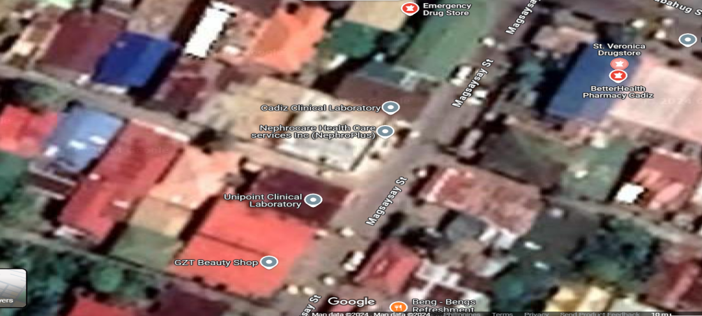

JTT PHARMACY

JTT Pharmacy

**Theoretical Framework**

Design

Requirements

Development

Testing

Deployment

Maintenance

The Medicine Store Management Platform for Small Pharmacies uses the Waterfall model for a step-by-step development process. It starts with collecting user requirements for key features such as medication ordering and inventory management. Each phase—requirements, design, development, testing, and maintenance—is completed in sequence, ensuring the system meets user needs and stays aligned with technological updates.

**Requirements Phase**

This phase involves gathering detailed information about the system's needs from stakeholders (such as pharmacy owners and staff). The goal is to identify key features like prescription management, inventory tracking, and user registration. The requirements are clearly documented to guide the entire development process.

**Design Phase**

In this phase, the system’s structure and layout are designed based on the gathered requirements. This includes designing the user interface, selecting the technologies to be used (such as programming languages and database), and planning the overall system architecture. The design phase ensures the system is user-friendly and meets all functional needs.

**Development Phase**

During this phase, the system is built according to the design specifications. Developers write code to implement features such as user login, inventory tracking, order processing, and payment integration. Third-party services (like payment gateways) are also integrated during this stage.

**Testing Phase**

The system undergoes rigorous testing to identify and fix bugs, ensure all features work as intended, and verify that it meets the requirements. Testing checks the system's functionality, security, and performance under different conditions to ensure reliability before launch.

**Deployment Phase**

Once testing is complete, the system is deployed for public use. This includes setting up the server, database, and configuring the system for real-world access. Users can now interact with the system to place orders and manage inventory.

**Maintenance Phase**

After deployment, the system enters the maintenance phase, where ongoing support is provided. This includes fixing any bugs that arise, updating the system with new features or improvements, and ensuring it remains secure and up to date with technological advancements. Regular updates help keep the system functional and efficient.

**Use Case Diagram**

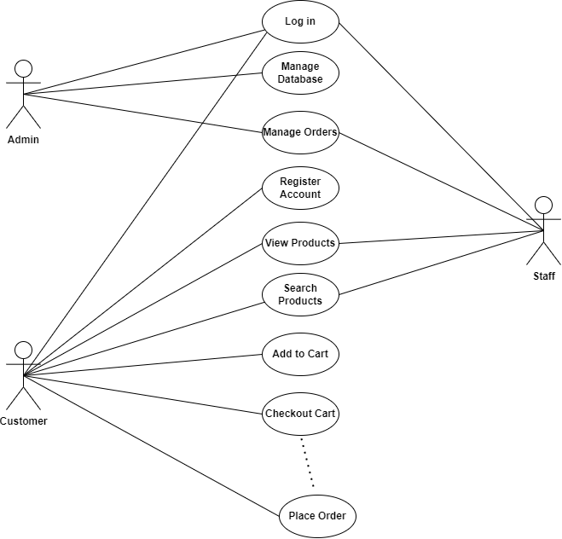

**Requirement Cost**

Description (admin) (user)

1. HARDWARE REQUIREMENTS

* Laptop (11th Gen Intel(R)

Core(TM) i5-1155G7 @ 2.50GHz 2.50 GHz, RAM 8.00 GB)

₱30,000 ₱0

* Server Computer (Intel Core I5 16GB 512 SSD) ₱42,000 ₱0

1. SOFTWARE REQUIREMENTS

* Web Framework (Laravel 11) ₱0 ₱0
* Operating System (Windows 11)

64-bit operating system, x64-based processor ₱10,000 ₱0

* Database Management System (MySQL) ₱0 ₱0
* Programming Language

( PHP, Node.js, HTML5, CSS5, and Javascript)

₱0 ₱0

* IDE/Development Tools (Visual Studio Code) ₱0 ₱0
* XAMPP control panel ₱0 ₱0

1. NETWORK REQUIREMENTS

* LAN/WI-FI (Fiber Home) ₱6000 ₱0
* Cloud Storage (Dropbox) ₱586 ₱0

IV. INTEGRATION REQUIREMENTS

* Payment Gateway Integration: (Gcash)

₱25,000 ₱0

* Twilio (SMS) ₱600 ₱0
* Version Control (Github) ₱0 ₱0
* Domain Provider (Hostinger ) ₱109 ₱0

TOTAL COST ₱114,295 ₱0

**Labor Cost**

**Poepleware Cost**

* Full Stack Developer ₱40,000
* Data Encoder ₱20,000
* Cashier ₱18,000
* Courier ₱15,000
* System Administrator ₱40,000
* QA Tester ₱25,000
* Technical Support Staff ₱20,000
* Pharmacist Consultant ₱30,000

**Gantt Chart**

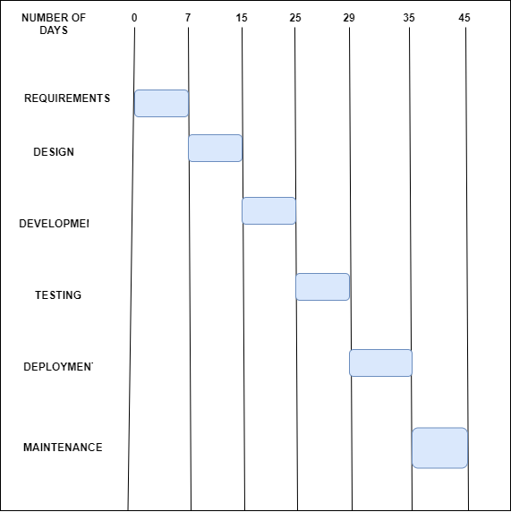

**System Prototype**

**View Products**

**Add To Cart**

**Homepage**

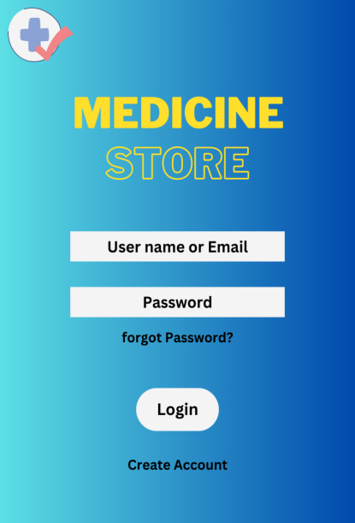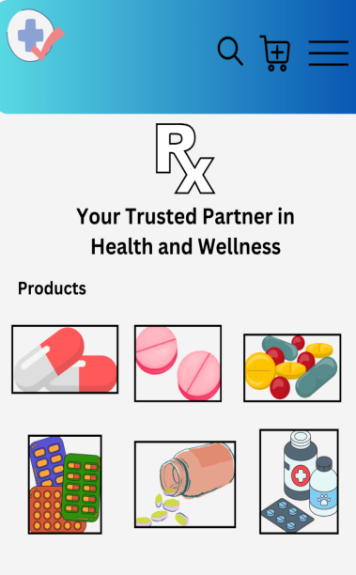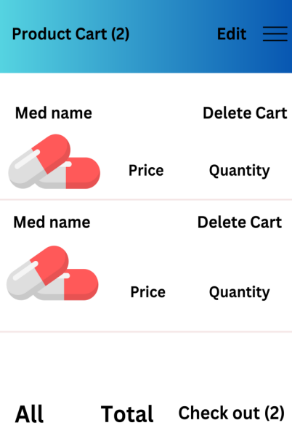

**Account Information**

**Checkout Page**

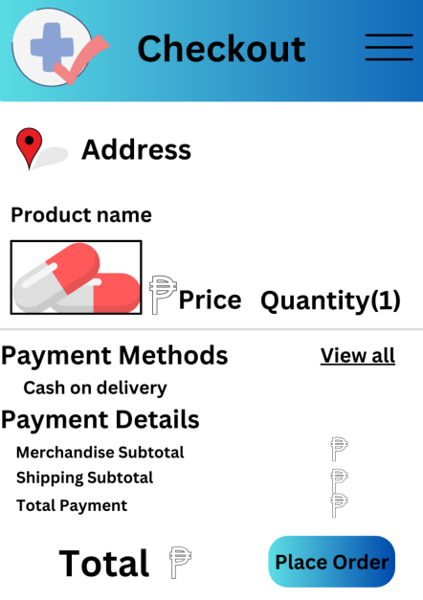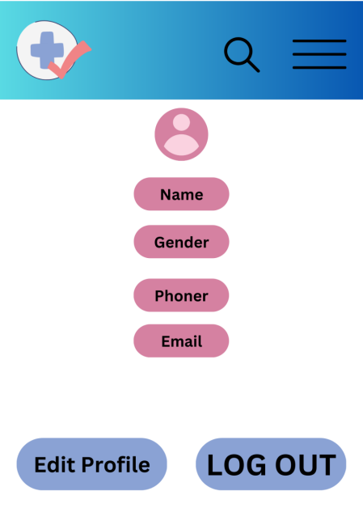

**Data Flow Diagram**

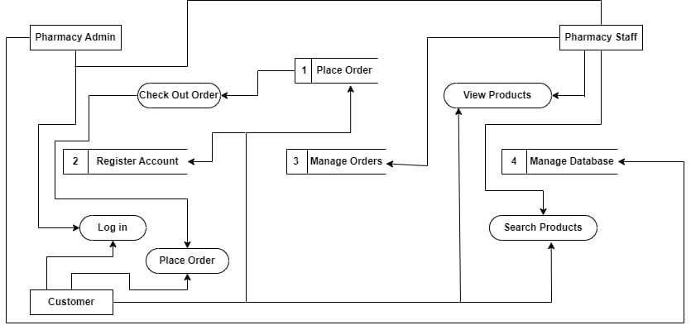

**Data Flow Diagram Level 0**

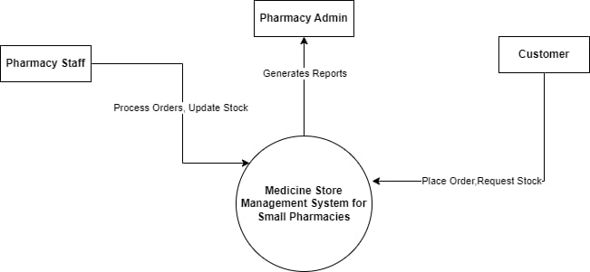

**ER Diagram**

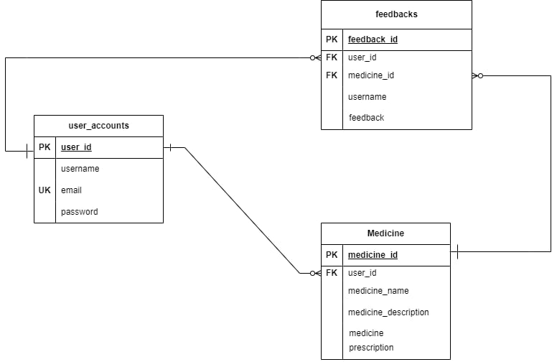

**System Architecture**

The Medicine Store Management Platform for Small Pharmacies uses a layered architecture to enhance functionality and security. This approach supports real-time inventory tracking for accurate stock monitoring and requires prescription uploads for restricted medications. Additionally, analytics tools offer insights into sales and customer trends to aid in better business decisions, providing a secure and user-friendly experience for both staff and customers.

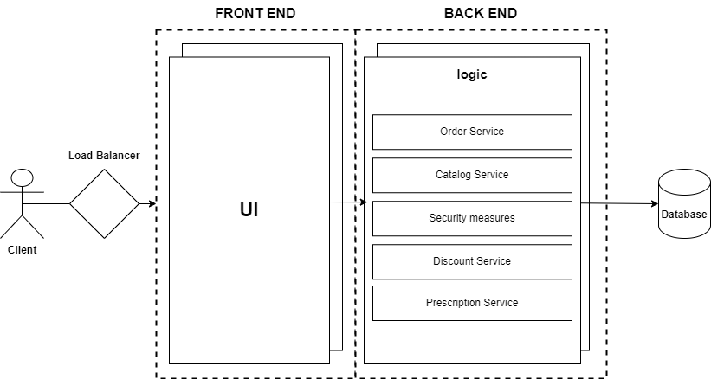

**PERT**

7

0

0

7

A

Requirements

15

7

Design

B

15

7

25

155

15

Development

C

25

29

25

D

Testing

25

29

29

35

E

Deployment

29

35

35

45

F

Maintenance

35

45

**CPM**

B

A

C

D

E

F

Total No. Of Days: 45 Days

Critical Path: A, B, C, D, E, F

**CHAPTER III**

**PRESENTATION OF DATA**

A survey was conducted as part of the requirements gathering phase for developing a Medicine Store Management Platform for Small Pharmacies, designed to provide small pharmacies with efficient tools to streamline operations, enhance customer satisfaction, and improve overall business performance.

Feedback was gathered from 15 respondents, consisting of 4 males (26.67%) and 11 females (73.33%), to evaluate the proposed features of the platform.

The questions were aligned with the ISO/IEC 25010 standard, and responses were collected using a Likert scale with the following options: Strongly Agree, Agree, Neutral, Disagree, and Strongly Disagree.

Strongly Agree

Agree

Neutral

Disagree

Strongly Disagree

**Figure 1. Responses on Functional Suitability of the Medicine Management Platform**

The majority of respondents (73.3%) strongly agreed, and 20% agreed, indicating that most participants found the platform’s features functional and promising. However, 6.7% strongly disagreed, suggesting potential concerns that need to be addressed for full acceptance.

The platform is projected to have high acceptance in terms of functional suitability, with positive feedback from most users. To ensure broader acceptance, it is recommended to address the concerns raised by the 1 respondent who disagreed, possibly by refining specific features or providing additional training and support.

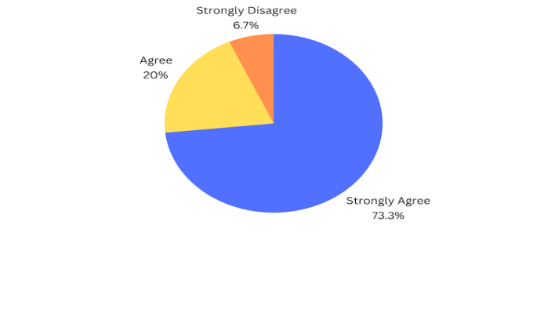

**Figure 2. Responses on Ease of Navigation of the Medicine Management Platform**

The results indicate that 9 out of 15 respondents (60%) strongly agreed, and 5 respondents (33.3%) agreed, reflecting an overall positive sentiment. Only 1 respondent (6.7%) strongly disagreed, highlighting minimal skepticism regarding the platform's ease of use.

The platform is projected to have high acceptance regarding ease of navigation. Addressing the concerns of the respondent who disagreed will help improve overall user satisfaction.

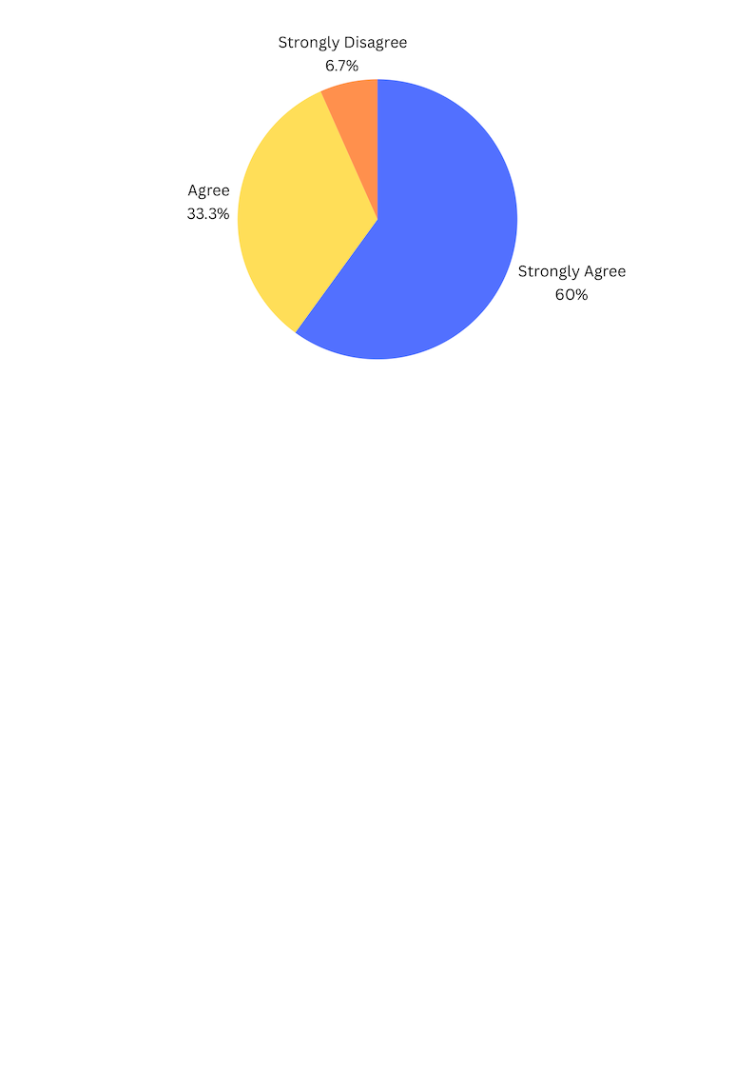

**Figure 3. Responses on Seamless Inventory Tracking**

According to the survey, 8 respondents (50%) strongly agreed, and 4 respondents (31.3%) agreed, showing confidence in the system’s tracking capabilities. However, 2 respondents (12.5%) were neutral, and 1 respondent (6.3%) strongly disagreed, indicating some reservations.

The platform is expected to perform well in inventory tracking. However, addressing the concerns of neutral and disagreeing respondents will be necessary to refine the system and boost user confidence.

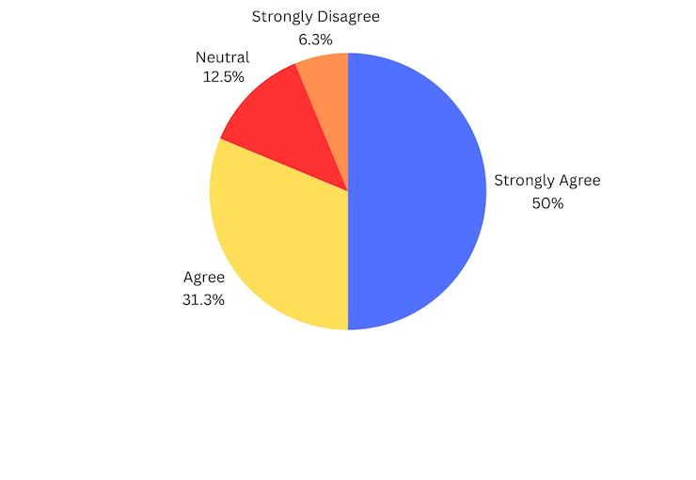

**Figure 4. Responses on Managing Customer Complaints and Feedback**

The data reveals that 8 respondents (53.3%) strongly agreed, and 6 respondents (40%) agreed, while only 1 respondent (6.7%) strongly disagreed. This suggests that most participants are optimistic about the platform’s capability to handle customer concerns effectively.

The platform is projected to perform well in managing customer complaints and feedback. Addressing the concerns of the respondent who disagreed will ensure better user satisfaction.

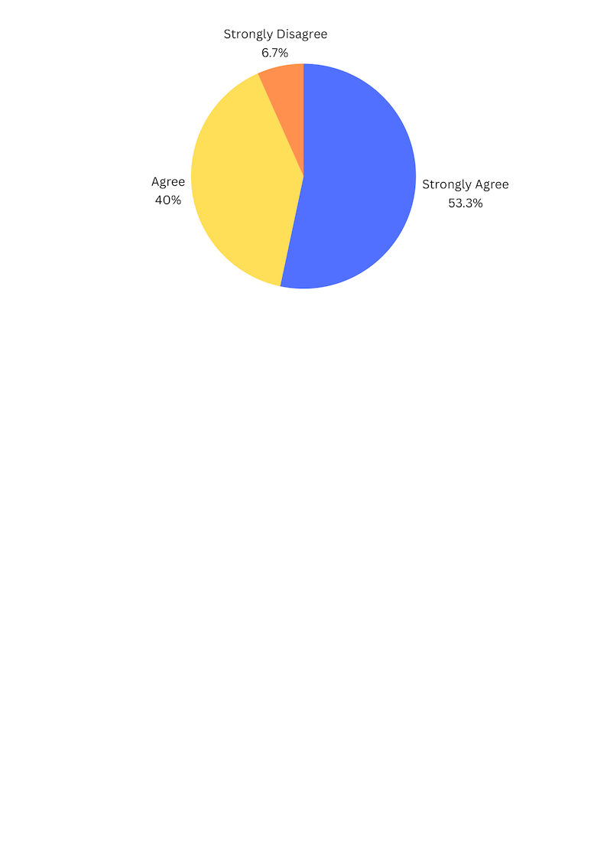

**Figure 5. Responses on Performance Efficiency**

As shown in the figure, 6 respondents (42.9%) strongly agreed, and 5 respondents (35.7%) agreed, while 3 respondents (14.3%) were neutral, and 1 respondent (7.1%) strongly disagreed. This highlights a generally positive perception, with some uncertainty about performance consistency.

The platform is expected to be well-received in terms of performance efficiency. Addressing the concerns of neutral and disagreeing respondents will be essential for improving consistency and user confidence.

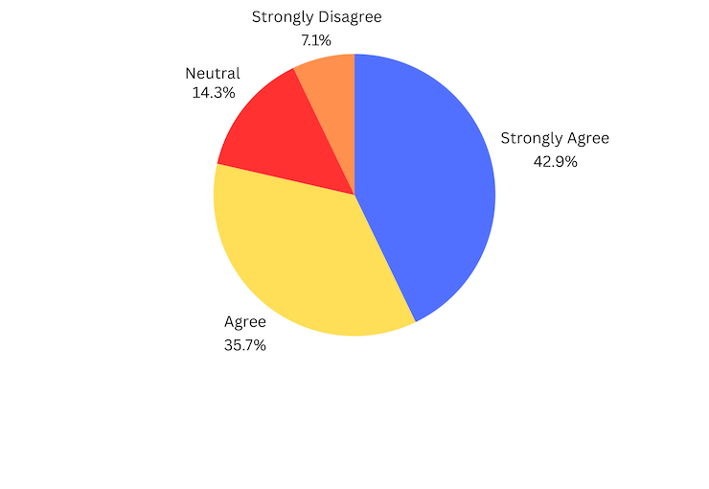

**Figure 6. Responses on Integration with Sales and Customer Service**

As shown in the figure, 6 respondents (33.3%) strongly agreed, and 5 respondents (33.3%) agreed, while 3 respondents (20%) were neutral, and 1 respondent (6.7%) strongly disagreed. This highlights a generally positive perception, with some uncertainty about performance consistency.

The platform is expected to be well-received in terms of performance efficiency. Addressing the concerns of neutral and disagreeing respondents will be essential for improving consistency and user confidence.

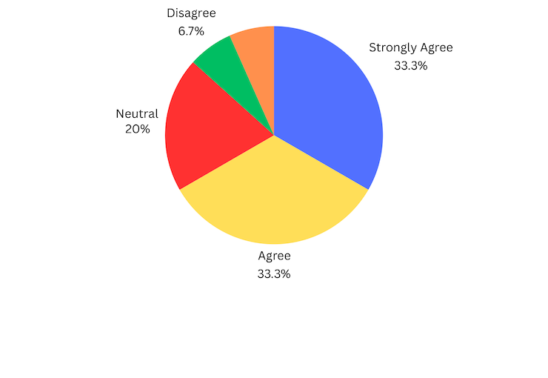

**Figure 7. Responses on Flexibility in Handling Stock and Product Variety**

According to the figure, 6 respondents (40%) strongly agreed, and 5 respondents (33.3%) agreed, while 3 respondents (20%) were neutral. Only 1 respondent (6.7%) strongly disagreed, indicating general confidence with minor concerns.

The platform is projected to be successful in handling stock and product variety. However, addressing the concerns raised by the single respondent who disagreed will improve its flexibility.

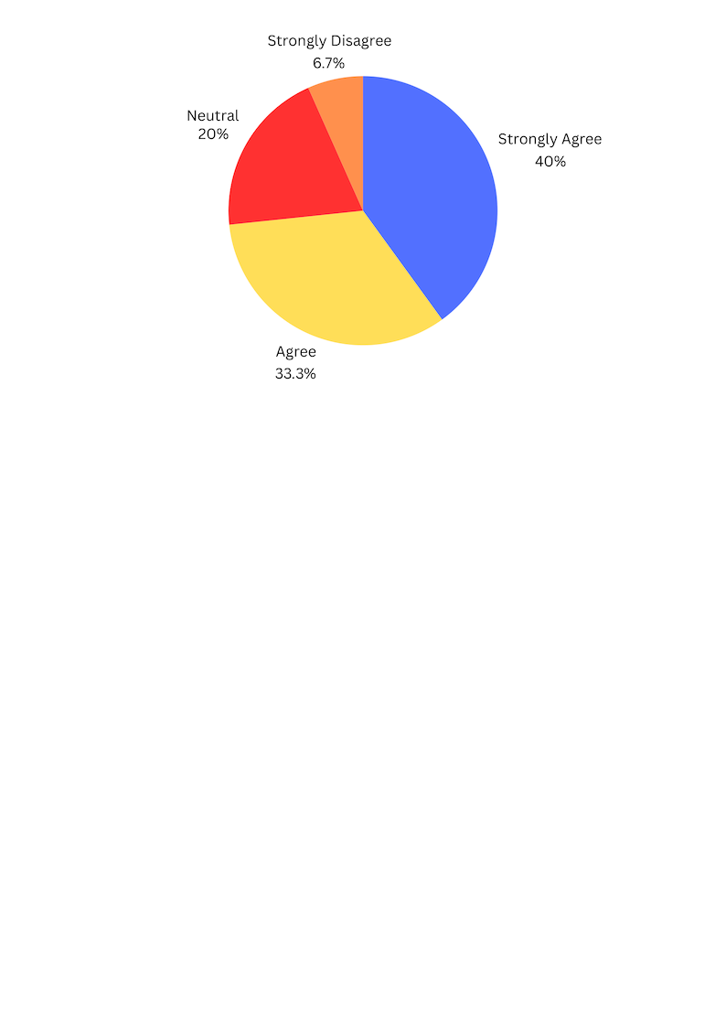

**Figure 8. Survey Responses on Supporting Customer Expectations**

The results show that 8 respondents (53.3%) strongly agreed, and 6 respondents (40%) agreed, with 1 respondent (6.7%) selecting neutral. This indicates a strong belief in the platform's ability to meet customer needs.

The platform is expected to meet customer expectations effectively. Attention should be given to the neutral response to ensure full satisfaction.

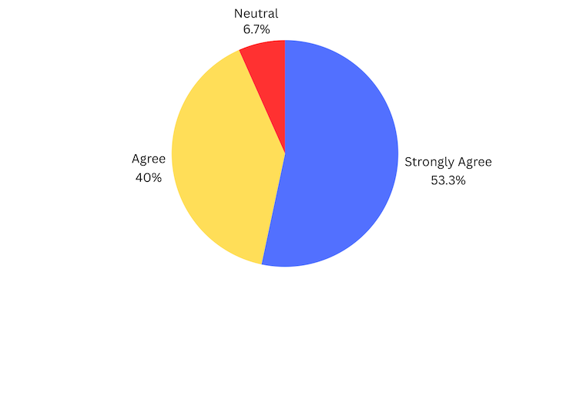

**Figure 9. Survey Responses on Data Reporting for Decision-Making**

The figure reveals that 8 respondents (53.3%) strongly agreed, and another 5 respondents (33.3%) agreed, while 2 respondents (13.3%) were neutral. This shows a generally positive outlook with some room for improvement in showcasing reporting features.

The platform is expected to perform well in data reporting. Enhancing the reporting features and addressing the concerns of neutral respondents will help improve decision support.

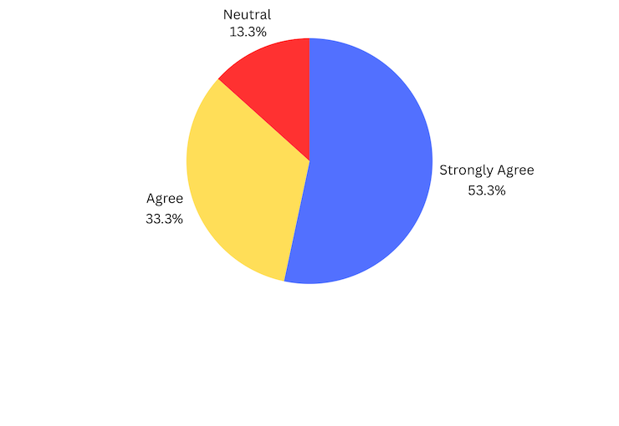

**Figure 10. Survey Responses on Efficient Stock Tracking**

As shown in the figure, 8 respondents (53.3%) strongly agreed, and 5 respondents (33.3%) agreed, while 2 respondents (13.3%) were neutral. This demonstrates high confidence in the system’s stock tracking capabilities.

The platform is projected to perform well in stock tracking. To further increase user confidence, addressing the neutral responses will help improve tracking performance.



**Figure 11. Survey Responses on Reliable Inventory Management**

As indicated, 6 respondents (40%) strongly agreed, and another 6 respondents (40%) agreed, while 2 respondents (13.3%) were neutral. Only 1 respondent (6.7%) strongly disagreed, reflecting a generally positive perception with slight skepticism.

The platform is expected to perform well in inventory management. Addressing the concerns of the respondent who disagreed will help improve overall trust in the system.

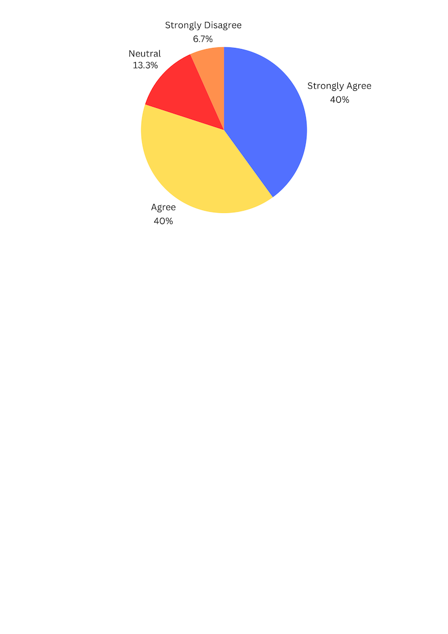

**Figure 12. Survey Responses on Minimizing Disruptions from Errors**

The figure highlights that 6 respondents (40%) strongly agreed, and another 6 respondents (40%) agreed. However, 1 respondent (6.7%) was neutral, and 2 respondents (13.3%) strongly disagreed, pointing to the need for error reduction.

The platform is expected to minimize disruptions caused by errors. However, addressing the concerns raised by the respondents who disagreed will be necessary for improving overall performance.

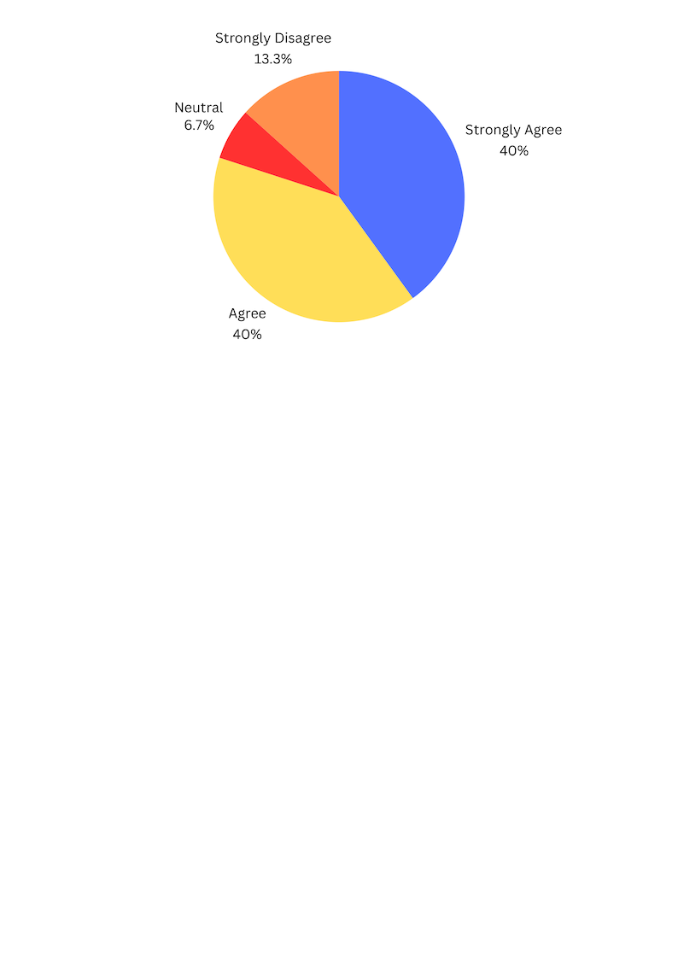

**Figure 13. Survey Responses on Security Features**

The survey indicates that 5 respondents (33.3%) strongly agreed, and 6 respondents (40%) agreed, while 3 respondents (20%) were neutral, and 1 respondent (6.7%) strongly disagreed. This underscores the importance of emphasizing robust security measures.

The platform is expected to be well-received for its security features. To increase user confidence, addressing the concerns of neutral and disagreeing respondents will help ensure a stronger security perception.

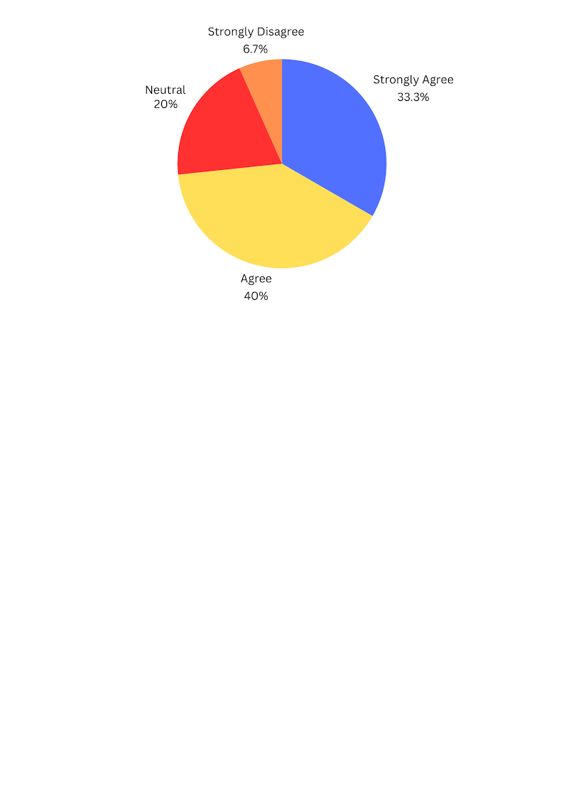

**Figure 14. Survey Responses on Maintainability**

The results show that 4 respondents (26.7%) strongly agreed, and 7 respondents (46.7%) agreed. However, 1 respondent (6.7%) was neutral, 1 respondent (6.7%) was disagree, and 2 respondents (13.3%) expressed strongly disagree, suggesting a need for improved maintainability.

The platform is expected to perform well in maintainability, but addressing the concerns of the respondents who disagreed will be necessary for improving long-term usability.

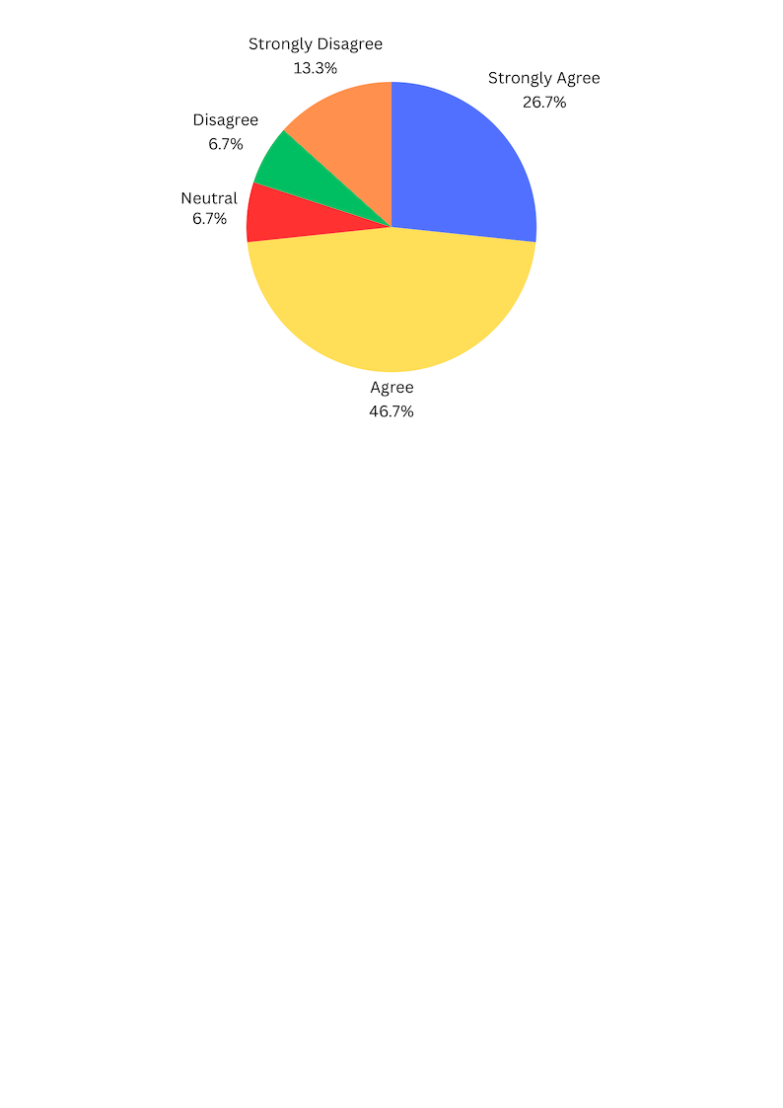

**Figure 15. Survey Responses on Portability**

The majority of 5 respondents (33.3%) strongly agreed, and 6 respondents (40%) agreed. Meanwhile, 3 respondents (20%) were neutral, and 1 respondent (6.7%) strongly disagreed, indicating a need for further enhancements in adaptability.

The platform is expected to be acceptable in terms of portability. However, addressing the concerns of the single respondent who disagreed will be important for improving adaptability.



**RECOMMENDATIONS**

The Medicine Management Platform has received mostly positive feedback, but there are areas that need improvement to ensure a better user experience. First, the platform should refine certain features to address the concerns of the few respondents who disagreed with its functionality and ease of navigation. Improving these areas, along with providing additional training and support, will enhance user satisfaction. The inventory tracking system is generally effective, but more work is needed to address the concerns of respondents who were neutral or disagreed, particularly by improving accuracy and usability. In terms of customer feedback management, focusing on improving responsiveness and handling customer concerns more effectively will boost user confidence. For performance efficiency, it's important to ensure consistency and stability, addressing concerns about performance under different conditions. The platform’s flexibility in managing stock and product variety is well-received, but addressing minor concerns will make it more adaptable. Ensuring the platform can effectively support customer expectations requires continuous feedback and improvements, particularly in areas where users expressed neutrality. Data reporting features should be enhanced to provide more insights for decision-making, addressing the neutral responses to improve usefulness. Stock tracking should be fine-tuned to ensure reliability across all use cases. The platform should focus on reducing errors and minimizing disruptions by addressing user concerns about system stability. Security features need to be strengthened by implementing more robust measures, such as encryption and regular security updates, to increase trust. Lastly, maintainability can be improved by ensuring the platform is easy to update and maintain, while portability should be enhanced for better compatibility across different devices and environments. By addressing these specific concerns, the platform will be more reliable, user-friendly, and widely accepted.

**CHAPTER IV**

**CONCLUSION AND RECOMMENDATION**

The Medicine Store Management Platform for Small Pharmacies is a system designed to help small pharmacies manage their operations, including inventory tracking, prescription handling, and customer orders, more efficiently. The main purpose of the Medicine Store Management Platform for Small Pharmacies is to provide a centralized and efficient solution for managing inventory, prescriptions, and customer transactions while enhancing overall operational accuracy and customer satisfaction.

**Conclusion**

Based on the testing and feedback, the system has been proven to effectively support small pharmacies by improving inventory management, ensuring accurate prescription handling, and simplifying order processing. It also reduces manual errors and provides tools for better decision-making through sales and customer trend reports. The system successfully achieves its goal of making pharmacy operations faster, more organized, and customer-friendly.

**Recommendation**

The researchers recommend implementing the Medicine Store Management Platform for Small Pharmacies to enhance daily operations and customer service. Training staff to use the system will ensure its features are fully utilized. Regular updates to the system are recommended to maintain its reliability and adapt to future needs.